Labour Market Statistics User Group 2021:
Participant questions and areas of interest Theme: Labour Market
November 2021
The Labour Market Statistics User Group took place online on Thursday 30th September 2021. This meeting included an overview of recent and planned developments in labour market statistics, and the presentation from this session is available from the Labour Market Statistics User Group 2021 page on the NISRA website. To increase engagement with users and obtain feedback, we utilised Mentimeter software at various stages throughout the meeting, and the following questions were asked:
- What organisation are you from?
- How could we improve NI jobs and earnings statistics?
- What are your emerging information needs and data gaps?
We received positive engagement from participants during these interactive sessions, which identified a number of overarching themes:
- More geographical data
- More timely data
- More detailed sectors
- Better access to data
- Generic queries
This document has a section for each of these overarching themes, where the specific points raised are included (and grouped where applicable) and relevant responses provided by survey area (as applicable).
As there are a number of updates, including action taken since the user group, a ‘summary of updates and action taken’ section has also been provided alongside ‘next steps’.
The final section includes how to get in contact with all Labour Market teams across Economic and Labour Market Statistics (ELMS) branch.
Contents
Summary of updates and action taken since User Group 3
Next steps 3
Detailed queries and responses 5
More geographical data 5
More timely data 6
More detailed sectors 7
Better access to data 9
Generic queries 10
Labour Market points of contact 11

Summary of updates and action taken since User Group
There are a number of updates to make users aware of following the user group, including action taken across the ELMS labour market team.
- HMRC PAYE RTI data
- Breakdowns by industry and age for NI now available for payrolled employees and earnings. NISRA released a number of posts on Twitter alongside the November 2021 Labour Market Report, with a focus on the impact by industry of the COVID-19 pandemic and a summary report is now available online.
- The QES team plan to include a section containing data from HMRC PAYE RTI on payrolled employees within the QES bulletin from December 2021.
- LFS data - additional data was included within the Labour Force Survey (LFS) annual tables 2020 release on 23rd November 2021 as a result of user feedback obtained during the user group:
- Economic inactivity by age for LGD – see ‘Labour Market Status’ document at above link, worksheet 1.10
- Employment and economic inactivity by LGD and disability status - see ‘Labour Market Status’ document at above link, worksheet 1.11
- Three new topic papers were released containing new analysis from the LFS:
- Disability Employment Gap in Northern Ireland 2020, was released on 7th October 2021
- Qualifications in Northern Ireland 2020 was released on 21st October 2021
- Young people not in education, employment or training (NEET): 2020 was released on 25th November 2021

Next steps
HMRC PAYE RTI
- Consider the new age and industry breakdowns from HMRC PAYE RTI and how this can be factored in to future LMR releases
- An ASHE v RTI comparison document will be published online before the end of the year
- Provide feedback to HMRC on request for public/private breakdowns.
LFS/work quality
- NISRA plan to release geographical breakdowns of key labour market estimates on a more frequent and timely basis
- New questions are being added to LFS in January to March 2022 on skills mismatch and gig economy, and NISRA will consider outputs from this when data available.
- Work quality publication is planned for Feb/March 2022 and plans are underway for format and content of this release and tables
QES and BRES
- Plan to publish all QES tables on the same page, aiming to have this complete by Q4 2021 publication. Aim to review format of QES 2 digit SIC tables for easier interrogation
- Aim to review the BRES data tables online content in 2021
- BRES 2021 data will be published in 2022 to 5-digit SIC and to District Council Area (DCA) and Parliamentary Constituency Area (PCA) levels.
Other
- Adhoc queries – ELMS continue to monitor emerging trends and requests to help shape and plan future topic papers and additional tables required.
- Query on people furloughed with a second job was forwarded to HMRC and the following response received: “Unfortunately it is not possible to obtain the information you requested as we do not have figures to hand on the number of people with a second job on furlough or data on people who were furloughed getting a new job. Obtaining this data would require additional analysis.” Announcements for CJRS statistics can be found at the following page: https://www.gov.uk/government/statistics/announcements/coronavirus-job-retention-scheme-statistics-16-december-2021

Detailed queries and responses

More geographical data
- Provide by LGD
- As timely and with the most detailed breakdowns as possible
- If stats are completed NI wide. Then broken down to smaller geographical areas.
- Publication of data at parliamentary constituency level
- To break down as small as possible in geographical area and sectors
- Any increase in the availability of Regional breakdowns would really add value- this is something my customers want
- Persuade hmrc to give more regional breakdowns
- Data gaps exist by LGD. NI wide data, important and informative as it is, is not a reflection of local data.
- Economic inactivity by gender, age at local level
- Can we get a breakdown of economically inactive by age sector and location?
- Can the work quality report provide breakdown of council level data
Employee job data from the Business Register and Employment Survey (BRES) is published at District Council Area (DCA) level every year and at Parliamentary Constituency Area (PCA) level every other year. DCA and PCA by headline and section level are available for 2019 on the BRES 2019 publication page. The BRES 2021 data will be published to 5-digit SIC and to DCA and PCA levels. Employee job counts are available to small NI geographies every other year from BRES. These data can be obtained by request or by contacting the BRES team.

The Quarterly Employment Survey (QES) provides industry breakdowns for employee jobs to 2-digit Standard Industrial Classification (SIC) on a quarterly basis.

Employee earnings data from the Annual Survey of Hours and Earnings (ASHE) is available for both work and home LGDs and Parliamentary Constituency Areas at NI geographies, by place of work and place of residence. Breakdowns are also available from ASHE for Industry, occupation, age, public/private sector and skill level.

More timely earnings and payrolled employees data from HMRC PAYE’s Real Time Information (RTI) is published each month and is available by DCA. New breakdowns by age and industry (at NI level) are now available, following release in October and November releases respectively, which will be available for these breakdowns on a quarterly basis.

Labour market data by Local Government District and Parliamentary Constituency is released on an annual basis from the Labour Force Survey (LFS), and 2020 data was released on the 23rd November 2021. Following the requests above, additional data was included within the LFS annual tables 2020 release, including:
- Economic inactivity by age for LGD – see ‘Labour Market Status’ document at above link, worksheet 1.10
- Employment and economic inactivity by LGD and disability status - see ‘Labour Market Status’ document at above link, worksheet 1.11
Economic inactivity broken down by gender is available in worksheets 1.2 and 1.3 within the ‘Labour Market Status’ document at above link.

The next work quality report is due for release in February/March 2022. We can consider if the data supports inclusion within supplementary tables.

- Have you ever analysed ASHE on home address? What is the difference? Curious with wfh and impact, anecdotally other half is now working for english company but based here, guessing that is growing pattern

The Employee earnings in NI 2021 publication plots home and work LGDs from ASHE in Figure 5. Further analysis into the proportion of employees who live and work in the same LGD has not shown any significant change over the last few years. This is most likely due to the nature of the work address question in the survey, which asks for the address of the employees’ usual site or office.

More timely data
- More close to real time data - perhaps using the HMRC data further
- As timely and with the most detailed breakdowns as possible

The Business Register and Employment Survey (BRES) publication date has been brought forward in recent years, with publication occurring within 5 months of the end of the data collection period. BRES 2021 surveys 35,000 businesses and significant processing. Our aim is to ensure a high level of accuracy balanced against timeliness of output.
NI Quarterly Employment Survey (QES) data are currently released to align with the publication of UK wide labour market statistics.
Earnings and payrolled employees data are released monthly from HMRC PAYE’s Real Time Information (RTI) at district council level. Following the release of additional breakdowns by age and industry (at NI level) in October and November, these will also be available on a quarterly basis going forward.
The monthly Labour Market Report includes data on payrolled employees and earnings from the HMRC PAYE’s Real Time Information (RTI), which includes flash estimates of data for the previous month. December’s QES publication will include a section containing data from HMRC PAYE’s RTI on payrolled employees for comparison and information purposes.
NISRA have plans to prioritise the release of labour market data on a more frequent and timely basis by Local Government District and Parliamentary Constituency from the Labour Force Survey during 2022. Due to the need to review and change the weighting methodology as a result of changes to data collection during the pandemic, the production of geographic breakdowns has been delayed in 2021.

- Could there be a ‘full move’ to RTI in future?
There are no current plans to fully replace the Annual Survey of Hours and Earnings or the Quarterly Employment Survey with RTI data. However, they are a useful supplement to the main ASHE earnings data and QES employee jobs estimates.

More detailed sectors
- Show second jobs by sector
The number of workers with second jobs and the number of hours worked by these people are included in the monthly LFS tables published alongside the Labour Market Report. Number of workers with second jobs by sector are available on request however, due to the small sample size in this area, a large proportion of the results may not be able to be released due to disclosure rules.

- Show jobs by age if possible and sector
- Sector breakdown of HMRC data. Both public and private and industrial
- More breakdowns
Additional breakdowns of payrolled employees and earnings from HMRC PAYE’s Real Time Information (RTI) were released by age for NI in October and by industry for NI in November 2021. NISRA released a number of charts and analysis on Twitter alongside the November 2021 Labour Market Report, which focussed on the impact by industry of the COVID-19 pandemic (Tweet 1, Tweet 2, Tweet 3, Tweet 4, Tweet 5) and a summary report is now available online. Figure 1 below shows an example of this additional analysis, and we are considering how to utilise this data further going forward. Following feedback from the 2021 Labour Market Statistics User Group, we will express a requirement for breakdowns by the public/private sector.

Figure 1: Change in payrolled employees from PAYE RTI, by sector, March 2020 to October 2021

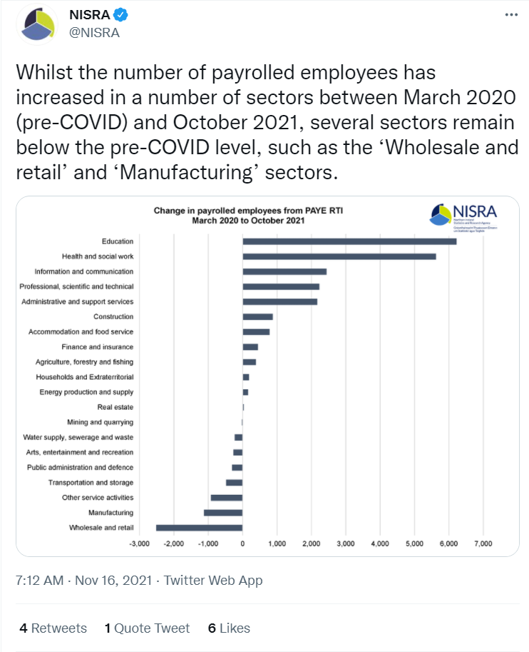

The latest data from the Business Register and Employment Survey (BRES) containing data at section level and to 5 digit SIC level is for 2019 which can be found on the BRES 2019 publication page. Quarterly Employment Survey (QES) data are available by gender, working pattern (full/part-time), public/private sector and industry sectors (down to 2-digit Standard Industrial Classification (SIC)). Age is not collected on the BRES or QES and therefore analysis is not possible from these sources.

- Disability, gender, LGD
- Can we get a breakdown of economically inactive by age sector and location?
Following these requests, additional data was included within the latest release of annual labour market data for 2020 from the Labour Force Survey on 23rd November 2021, including:
- Economic inactivity by age for LGD (sector is not possible) – see ‘Labour Market Status’ document at above link, worksheet 1.10
- Employment and economic inactivity by LGD and disability status - see ‘Labour Market Status’ document at above link, worksheet 1.11

We also released a topic paper containing new analysis on the Disability Employment Gap in Northern Ireland 2020 on 7th October 2021, which also examines the gap by gender.

- Data on people in low hours and zero hours who work beyond those hours
A user request was completed for in employment on Zero Hours Contract by industry. Sample sizes are low for those on zero hours contracts and therefore further analysis is limited. We will however consider this request.

- I like the draft pfg tables from 2019 but I’d like it for whole workforce, not just those in employment, would help with equality screening
The latest release of LFS annual tables 2020 on 23rd November 2021 contains data on persons 16 or over or those aged 16 to 64. As the monitoring of the previous draft NI Programme for Government (PfG) Outcomes Framework ceased in May 2021, there are no plans to update the current 2019 indicator tables for 2020.

- Are there any plans to publish religion data from LFS?
Religion data was included within the Draft NI Programme for Government (PfG) indicator tables, where the latest data available is 2019 and can be accessed at the Annual Report Tables 2019 page. We will consider this request for future LFS annual tables.

- Possibly focus on ad-hoc issues of relevance. E.g. Number of HGV drivers. Is that detail possible?
NISRA publish short topic papers containing adhoc analysis outside of our regular labour market outputs, and we release labour market user requested data on the NISRA website. A request was completed recently related to the Number of Large Goods Drivers in employment by country of birth and age. The Reporting Reliability in User Requested Data document (accessible at above link) contains the latest information on the LFS policy for ad-hoc queries, including where data is suppressed under disclosure threshold rules.

- On the dashboard it would be good to see an employment composition across sectors using BRES and compared against GB
The BRES team will consider adding employee jobs by sector comparison for NI and GB in the BRES 2021 output. The publication of NI employment data by NISRA is under review.

Better access to data
- Make it clearer to users that SIC level data can be found in the historical data section. Possibly merge into supplementary tables page or create new page for all data tables?
Following this useful feedback, the Quarterly Employment Survey (QES) team will look into publishing all QES tables on the same page and hope to have this in place for the Q4 2021 publication.
The Business Register and Employment Survey (BRES) team aim to review the online content in 2021, including historical data. In the interim, we will happily provide data on request – please contact the BRES team.

- Keen to get further detailed understanding of stress in retail/hospitality and impact of spend local scheme
The Department for the Economy (DfE) released an infographic in October providing information on the take up rate for the High Street Spend Local Scheme. DfE plan to publish further analysis once the scheme has closed.

- Align hmrc earnings with ashe, give estimates at larger margins of error as in lfs, an estimate is better than no estimate, qes is fab but time series on 2 digit sic could be better as all on separate tabs
An ASHE v RTI comparison document will be published online before the end of the year. This will detail the similarities and differences between the two data sources, and will plot the general trends over time.

Following this useful feedback we will improve the format of the QES 2-digit SIC tables to make them easier to use and interrogate.

- Improve self-employment data available on a time frequent basis (i.e. quarterly). The sample size is quite small from the LFS, and self employment numbers look very volatile in a time series. Is there any possibility to avail of admin data to help?
We continue to monitor the data available in this area and if suitable administrative data is sourced it will be incorporated into the analysis of the self-employed workforce. A topic paper covering self-employment in Northern Ireland was published in 2020 and can be found here: Self-employment in Northern Ireland 2019 (nisra.gov.uk).

- Will there be any data on people who were furloughed getting a new job?
Furlough data collected from the ASHE are provided for contextual purposes in the Employee earnings in NI 2021 report. Although it is not possible to report on those who were furloughed getting a new job, changes in proportions of employees furloughed are reported.
It is not possible to provide this from the QES, and the following response was obtained from HMRC in regards to this information “Unfortunately it is not possible to obtain the information you requested as we do not have figures to hand on the number of people with a second job on furlough or data on people who were furloughed getting a new job. Obtaining this data would require additional analysis.” Announcements for CJRS statistics can be found at the following page: https://www.gov.uk/government/statistics/announcements/coronavirus-job-retention-scheme-statistics-16-december-2021 ”.

- Any way to report ‘people taking advantage of furlough’?
There is no data available for this.

- Work with UK data service to ensure key variables that are important for NI are included in the non secure access LFS microdata file. Eg. cannot currently identify people identifying as Irish (they are included within the EU category).
We are in regular contact with labour market colleagues in the Office for National Statistics to ensure data important to users in NI is included within LFS microdata. Data is available for people identifying as Irish and this is available on request.

- I’d like a sic 2 digit by 3 digit soc to be published regularly
Due to the sample sizes of the LFS it would not be possible to publish a table showing 2-digit SIC by 3-digit SOC breakdowns.

- Zero hour contracts and gig sector, 'posted workers' from the EU to NI
Experimental questions on the gig economy are being launched on the LFS questionnaire in January to March 2022, which will be subject to further development.
Sample sizes are low for zero hours contracts which restricts the analysis that can be carried out and the results which could be published. A user request was completed for in employment on Zero Hours Contract by industry.

- Work quality
The area of work quality is new and evolving, and a new area has been created on the NISRA website for work quality to allow for easier access to publications and data. This also includes a work plan for 2021-2022. The next update for work quality is planned for Feb/March 2022 and we are currently planning the format of the report and tables to be included.

- Is there a correlation between the increase in UC claimants in the Claimant Count and people being placed on furlough and therefore having 80% income and being placed into low income?
We are continuing to monitor the make-up of the claimant count and numbers on furlough. When definitive conclusions can be drawn from these data sources, this will be reported.

- Is there any way to get a measure of the impact of skills shortages? This will be the impediment to economic growth
- Anything that gives an indication of where the supply could work in future would help, like does are inactive who want to work have previous occupation as an lgv driver
A new question is being added to the Labour Force Survey in early 2022 related to skills mismatch, and we will consider what analysis can be provided in due course. The 2021 Census Outputs Consultation also contains a proposal on skills mismatch.
The Department for the Economy (DfE) carry out research in the area of the supply of labour. The latest research can be found on the Skills and Employment page on the DfE website.

Generic queries
- Soc2020 only add minor changes including security services, is that right?
Details on the differences between SOC10 and SOC20 can be found at SOC 2020 - Office for National Statistics (ons.gov.uk).

- Is there anything local authorities can do to help with Survey response rates either for business surveys or domestic household surveys?
We are happy to work with Local Authorities to help improve survey response rates for business and household surveys.

Labour Market points of contact
To get in touch with the respective areas, please contact the email address provided below.
Area | Email
Labour Force Survey (LFS)  Work quality | LFS@finance-ni.gov.uk
Claimant Count | claimantcount@finance-ni.gov.uk
Redundancies | redundancies@finance-ni.gov.uk
Annual Survey of Hours and Earnings (ASHE) | ashehelpline@finance-ni.gov.uk
HMRC RTI | Ashleigh.warwick@nisra.gov.uk (employees and earnings)  Lynda.kennedy@nisra.gov.uk (employees)
Business Register and Employment (BRES) | Arlene.connolly @nisra.gov.uk
Quarterly Employment Survey (QES) | Lynda.kennedy@nisra.gov.uk
ELMS dashboards | Niall.O'Neill@nisra.gov.uk

