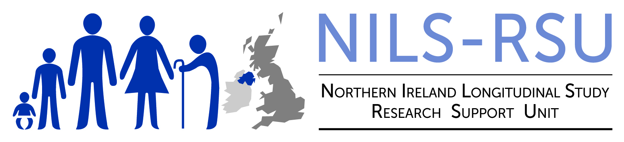 | NILS/NIMS  PROJECT MODIFICATION FORM
Project Name:

Project Number: | Research Support Officer:
Is the Project a DLP? | Has the Project been extended previously? If yes, how many times?
How many previous Project modifications have been submitted?

Researcher(s) Name:

Summary of Change:
(e.g. expanding to more age groups, more variables, or more up to date data).

Justification of Change & Other Relevant Information:
Please consider the following:
Does the proposed change alter the aims/objectives of the research? If so, how?

Does the proposed change increase/reduce the robustness of the methodology? If so, how?

Does the proposed change increase/reduce the probability of the outcome being achieved? If so, how?

Possible implications (to be completed by Support Officer):

