

**Northern Ireland Longitudinal Study-Research Support Unit**

**Annual Report 2021/22**

**April 2022**

 

cid:image002.png@01D802EC.4142BDA0

Contents

1. Background 3

2. Current NILS Data Structure 4

3. Current NIMS Data Structure 5

4. Data Release Schedule 5

5. Researcher Access to NILS 6

6. Ethical Approval of NILS Database 6

7. NILS Governance 7

8. NILS Developments 7

9. NISRA Secure Environment 8

10. NILS-RSU Online 9

11. Promotional/Dissemination Activities 9

12. Upcoming Dates 11

13. RSU Metrics 1 April 2021 – 31 March 2022 12

14. RSU Contact Details 14

# Background

The Northern Ireland Longitudinal Study (NILS) has been formally available to researchers since the end of 2006. It comprises two major data linkage studies: the NILS and the Northern Ireland Mortality Study (NIMS). The NILS and NIMS are designed for statistics and research purposes only and are managed by NISRA under Census legislation. The data are de-identified at the point of use; access is only from within a strictly controlled secure environment and governed by protocols and procedures to ensure data confidentiality.

The NILS is a large-scale, representative data-linkage study created by linking data from the Northern Ireland Health Card Registration System (Business Services Organisation) to the 1981, 1991, 2001 and 2011 Census returns and to administrative data from other sources.  These include vital events registered with the General Register Office for Northern Ireland (such as births, deaths and marriages) and the Health Card Registration System migration events data. The result is a 30 year plus longitudinal data set which is regularly being updated. In addition to this rich resource, there is also the potential to link further Heath and Social care data via Distinct Linkage Projects (DLPs).

The NIMS is a large-scale data linkage study that links the 1991, 2001 and 2011 Census returns for the whole of the enumerated population (approximately 1.6 million individuals) to subsequently registered mortality data from the General Register Office (GRO). While larger than NILS, it is more limited in scope, focusing only on the linkage of mortality data. The NIMS dataset is recommended to researchers whose primary interest is in mortality in Northern Ireland.

The NILS and NIMS are powerful research resources which allow exploration of health and socio-demographic characteristics. The data is of interest to a diverse variety of researchers and policy-makers UK-wide and can be used in areas such as equality analyses, demographic trends, mortality studies, the impact of policies and the planning of services.

The NISRA Research Support Unit (RSU) is the support unit for the NILS and the ADRNI. Both functions are funded by the Economic and Social Research Council (ESRC) and are similar in nature.

This mid-year report describes the work of the RSU relating to the NILS from 1 April 2021 to 31 March 2022.

# Current NILS Data Structure

The latest NILS data release was completed in February 2022. This release includes April 2021 data from the NI Health Card Registration System, Census data from 1981, 1991, 2001 and 2011, GRO Births data from 1974 to December 2019, GRO Deaths data from 1991 until December 2020, Marriages data from January 2005 to December 2019, Properties data updated to April 2021, Weather data from 1981 to December 2010, Pollution data from 2001 to December 2019 and School enrolment data for 2010/11. The current structure of the NILS data is shown below.

**Figure 1: NILS Data Structure**

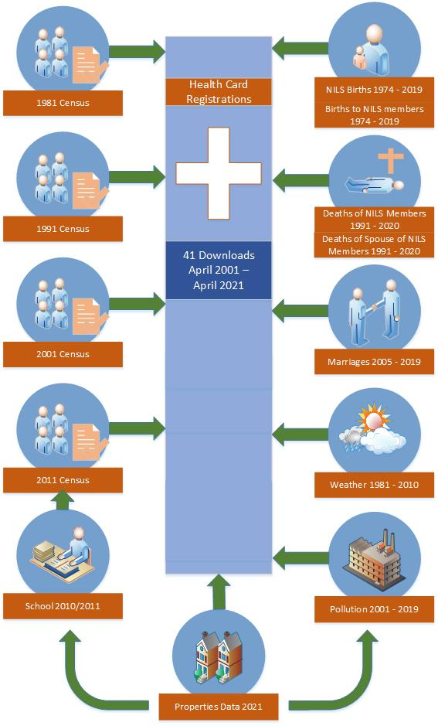

# Current NIMS Data Structure

The latest NIMS database (released March 2022) includes GRO Deaths data from 2011 to September 2021 linked to 2011 Census data, Weather data from 1981 to December 2010 and Pollution data from 2001 to December 2019.

Given the ongoing Covid pandemic, the 2011 NIMS study will be extended and remain active for an additional 4 years linking deaths up to the end of 2025. In addition, from November 2021, the biannual NIMS death updates have moved to quarterly updates. These changes, along with the addition of a Covid indicator variable within the NIMS database, should prove valuable for upcoming research on the Covid pandemic.

**Figure 2: NIMS Data Structure**

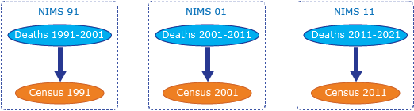

# Data Release Schedule

An updated NIMS database is planned for release in June 2022 to include deaths data up to December 2021. Following this, an updated NIMS database will be released quarterly to enable timely research on the Covid pandemic.

The next NILS data release is planned for July 2022. The NILS release will include data up to April 2021 from the NI Health Card Registration System and GRO events data from the Registrar General Annual Report up to December 2020.

It should be noted that the data release timetable is dependent on when data providers transfer data to RSU. RSU will endeavour to let users know as soon as possible if there are any issues with a scheduled release.

Discussions have begun with Census on the linkage of the 2021 Census data to the NILS. The Census release schedule proposes that work on adding the Census 2021 into the NILS will begin in early 2023. RSU have prepared a NILS Census 2021 Linkage Process Map to detail the potential timelines involved in the different phases of the linkage process.

1. Researcher Access to NILS

All researchers who wish to access de-identified micro-data within the NISRA secure environment, via NILS or ADR Northern Ireland, must now undergo the ONS Accredited Researcher process prior to the commencement of an approved research project. The researcher must apply for Research Accreditation using the ONS online Research Accreditation Service. This process includes the completion of a Safe Researcher training course.

The researcher must also agree to their inclusion in a list of all Accredited Researchers published on the UK Statistics Authority website. The details of researchers previously accredited via NISRA, who agreed to have their details transferred by RSU, have been added to this list.

# Ethical Approval of NILS Database

RSU submitted the NILS Research Database Annual Progress Report to the Office for Research Ethics Committees Northern Ireland (ORECNI) in August 2021. This report detailed the NILS projects approved, NILS projects that obtained additional ethical approval and all final outputs produced between 1 August 2020 and 31 July 2021. No further information was requested from ORECNI.

The favourable ethical opinion for the NILS research database was due to expire on 30 May 2022. In early March 2022, a fresh application to renew the opinion was submitted to ORECNI along with supporting documentation. RSU attended a meeting of the Research Ethics Committee on 29 March 2022 at which the application was reviewed. The NILS database received a favourable ethical opinion, which has been renewed for a further period of five years until 1 June 2027.

# NILS Governance

NILS-RSU continues to organise and attend the NILS Research Approvals Group (RAG) meetings and provide an induction to any new RAG members. RAG meetings were held in April June and October 2021 and in February 2022.

The exclusion of health bodies in the DEA resulted in ADR-NI health research using primary healthcare data being permitted through the NILS environment. Therefore, the RAG have been reviewing both ADR-NI and NILS applications.

Between 1 April 2021 and 31 March 2022, a total of 6 projects and 7 project modifications have been submitted for review to the NILS Research Approvals Group. A further 30 project modifications submitted by researchers have been approved and completed by RSU.

# NILS Developments

Synthetic Data

Researchers using the NILS can now apply for a project specific univariate synthetic dataset to facilitate the remote writing of code without needing access to the real data and the secure environment. This product has been a valuable addition to the service offered to researchers during the period of Covid-19 restrictions. Since April 2021, RSU have completed four requests for synthetic data.

An online synthetic data resource is due to be published on the Research Support section of the NISRA website in summer 2022. This will allow researchers to create their own synthetic datasets. Metadata and other supporting material are being prepared to accompany the online synthetic data resource.

Remote access

NISRA have worked in collaboration with ONS to provide remote access using the ONS Secure Research Service (SRS) in order to increase access to NI data for researchers. An ADR NI project using a new dataset called the Earnings and Employees Study (EES) 2011 was identified as a pilot for testing provision of remote access using the ONS SRS in NI. The EES 2011 links variables from the Annual Survey of Hours and Earnings 2011 with variables from the Census of Population and Housing 2011, and Capital Value from the Land and Property Service. The pilot project was made available to researchers on the ONS SRS in early November 2021. NISRA carried out an evaluation of the use of the ONS SRS for the EES project to see how this can be replicated with other NISRA datasets.

Use of secondary care data in the NILS

A pilot NILS project ‘Social and Economic Determinants of Maternal Obesity’ to streamline data linkage with the Northern Ireland Maternity Service is ongoing. Data Access Agreements, which enable the sharing of data with NISRA from the Honest Broker Service (HBS) directly, have been agreed and signed by individual Trusts and the BSO. RSU have received the data for this project and are completing statistical disclosure control checks on the final data extract.

An evaluation of this project and the NILS Process Map for Health Data (developed in 2019 by NISRA) have been completed in order to form recommendations to streamline the process for researchers accessing secondary healthcare data in the NILS.

Metadata

A project application to convert the structure of the Earnings and Employees Study metadata within RSU to international standards has been accepted by the NISRA Tech Lab. Once completed, this project will provide RSU with the tools and skills to create the NILS and NIMS metadata to the same standards. It is expected that the project with the NISRA Tech Lab will commence in mid-2022.

# NISRA Secure Environment

Following on from the easing of restrictions from the NI Executive, RSU reopened the secure environment to researchers from 1st June 2021.  Since then the secure environment remained open on a restricted basis to researchers (with the exception of a closure in Jan and Feb 2022 due to additional Covid restrictions that were in place).

RSU staff have continued to attend Colby House each week in order to maintain infrastructure, to create project specific data extracts, to clear outputs and to supervise researchers. RSU also continues to facilitate access to the ONS Secure Research Service within the NISRA secure environment.

The RSU booking request system, introduced in June 2021, allowed researchers to request time slots to attend the secure environment each week. A rota based seating plan for the secure environment accompanied other measures that were in place to reduce risk in the room. From April 2022, in line with the NICS Recovery Plan and as the NICS transitions into hybrid working, RSU will work to increase the capacity with the secure environment as restrictions ease.

# NILS-RSU Online

Information for researchers continues to be added to the NILS website (www.nils-rsu.co.uk). A new learning resources section is currently under development on the website.

Complementary to this, the NILS page under the Research Support section of the NISRA website ([www.nisra.gov.uk/support/research-support](http://www.nisra.gov.uk/support/research-support)) has continually been updated to ensure information for researchers is kept up-to-date. This includes an additional section on Univariate Synthetic Data and Ethics Applications for NILS projects.

Twitter has been used a number of times to share information with users and to publicise and promote the NILS and NILS events more widely. RSU is working to increase the social media presence of the NILS using National Awareness Days on Twitter to highlight related projects and publications arising from the NILS. Publicised hashtags have also been used to highlight NILS work. The NILS-RSU Twitter account now has 455 Twitter followers.

1. Promotional/Dissemination Activities

Following the announcement of the COVID-19 pandemic and the subsequent imposed restrictions, we have had to revise our programme of engagement. There has been a rapid transition to working online and hosting of virtual events in every sector and within the NILS team we have also been working to develop a strong online presence. The re-design of the NILS-RSU website has provided a good platform for this move.

We have also developed a social media strategy in collaboration with the other UK LS’s in order to complement and increase traffic to the new website.

* A new NILS explainer video is now live on the [NILS-RSU website](https://www.nils-rsu.co.uk/app/uploads/2021/09/NILS_V004.mp4).
* We continue to work with researchers to produce case studies of high public interest projects to be showcased on the [NILS-RSU website](https://www.nils-rsu.co.uk/case_studies/narrative-case-1/), together with a brief video synopsis.
* We gained ESRC Impact Acceleration funding for an ‘Effective Briefs for Policymakers’ workshop hosted by Bulletin (a strategic communications consultancy) which was held within the last reporting period. Additionally, the funding was used to hire a Research Assistant for 6 months. Danielle started on 1 June 2021 and worked on two strands. Firstly, she has collated a working document used to scan for policy and evidence calls in a number of countries and secondly, she has compiled and synthesised evidence from existing NILS projects within themed templates with the hope that these can be used as a basis to answer the aforementioned policy calls. This position was specifically aimed to enhance policy impact from the NILS.
* We ran a summer placement for 6 weeks with an undergraduate student in a capacity building exercise. The undergraduate student shadowed Estelle Lowry in her work in data analysis and NILS activities. As well as obtaining Accredited Researcher Status, the undergraduate student learnt how to use R and SPSS software, how to approach and carry out data analysis to answer a specific research question and how the research and evidence produced can feed into council initiatives and programmes. This placement programme was deemed successful and will be offered again next summer.
* We are planning a series of online resources for NILS users including a tutorial on the data formats and linkages provided for approved projects using the synthetic data. These tutorials should allow users to optimise their reduced time within the secure environment by focusing on the actual analysis and should provide a valuable training resource for capacity building.
* We have begun to create and develop a guidance document for Distinct Linkage Projects which will include a template for an ORECNI application.
* On 14 September we held our first joint ARK webinar - a workshop on the potential of NILS for Covid-related research. Panel members represented the Public Health Agency, Honest Broker Service, NISRA Research Support Unit, The Executive Office and QUB. Approximately 50 participants attended the workshop. It was a very informative session discussing relevant data availability and feasibility of projects. The webinar recording has been viewed on YouTube and a summary of the discussions and event can be found on the [NILS-RSU website](https://www.nils-rsu.co.uk/the-potential-of-ni-longitudinal-study-for-covid-research/). The success of this event during a period of Covid restrictions has demonstrated the effectiveness of using webinars to communicate with researchers. Plans are in place to host further online events to communicate upcoming RSU projects.
* Two abstracts were accepted for the CLOSER conference (Tackling key challenges facing longitudinal population studies in a post-COVID world) in January – one on Participant and Public Engagement detailing our collective intelligence approach and the other on how we are supporting covid-related research. These were well received and we had some follow-up engagement.
* We are also working with the other UK longitudinal studies to host a conference in Autumn 2022.
* In response to feedback received from the ARK seminar, we are working on the creation and facilitation of themed working groups to answer relevant questions for NI using appropriate administrative data. We have been finalising a document detailing their remit and scope and composing a potential mailing list to record interest in membership of these groups.

# Upcoming Dates

**NILS Research Approvals Group**

Future NILS RAG meeting dates and the corresponding deadline dates for the submission of a project application or modification are listed below:

|  |  |
| --- | --- |
| **NILS RAG Deadline Dates 2022** | **NILS RAG Meeting Dates 2022** |
| 22 March | 5 April |
| 7 June | 21 June |
| 13 September | 27 September |
| 15 November | 29 November |

Researchers must ensure that RSU have seen an initial draft of a project application ahead of the deadline date in order that feedback and comments can be provided from RSU in advance of the RAG meeting.

# RSU Metrics 1 April 2021 – 31 March 2022

The following metrics are for the period 1 April 2021 – 31 March 2022.

Table 1: NISRA Secure Environment Bookings

|  |  |
| --- | --- |
| Number of distinct bookings for secure environment | 241 |
| Number of distinct researchers who have booked into secure environment | 19 |

Table 2: Project Totals at 30 September 2021

|  |  |  |
| --- | --- | --- |
|  | NILS/NIMS Projects | ADR Projects in the NILS Environment |
| Number of Projects | 91/40 | 19 |
| Number of Active Projects | 13 | 9 |
| Number of Completed Projects | 101 | 2 |
| Number of Pending Projects | 4 | 8 |
| Number of Distinct Linkage Projects  (Includes active and pending projects) | 2 | 15 |

Table 3: Approved/Completed Projects

|  |  |  |
| --- | --- | --- |
|  | NILS/NIMS Projects | ADR Projects in the NILS Environment |
| Number of projects approved | 1 | 5 |
| Number of projects completed | 4 | 1 |

Table 4: Outputs and Modifications

|  |  |  |
| --- | --- | --- |
|  | NILS/NIMS Projects | ADR Projects in the NILS Environment |
| Number of Project Modifications | 23 | 14 |
| Number of Final Outputs | 26 | 25 |
| Number of Intermediate Output Requests/Files | 48/114 | 39/220 |

Table 5: Number of Project Modifications by Type

|  |  |  |
| --- | --- | --- |
| Modification Type | NILS/NIMS Projects | ADR Projects in the NILS Environment |
| Additional Variables added | 5 | 3 |
| Extension to end date | 10 | 5 |
| Additional data added | 0 | 0 |
| Researcher added to project | 4 | 2 |
| Request for Univariate Synthetic Data | 1 | 3 |
| Other | 3 | 1 |
| **TOTAL** | **23** | **14** |

Table 6: Number of Final Outputs by Type

|  |  |  |
| --- | --- | --- |
| Output Type | NILS/NIMS Projects | ADR Projects in the NILS Environment |
| Article | 3 | 0 |
| Paper | 2 | 2 |
| Research/Policy Brief | 6 | 1 |
| Presentation | 3 | 10 |
| Abstract | 1 | 4 |
| Blog | 0 | 2 |
| Other | 11 | 6 |
| **TOTAL** | **26** | **25** |

Table 7: Number of NILS/NIMS Intermediate Output Requests/Files by Project

|  |  |  |
| --- | --- | --- |
| NILS Project | Requests | Files |
| 066 | 29 | 33 |
| 106 | 7 | 48 |
| 122 | 1 | 2 |
| 123 | 2 | 2 |
| 126 | 3 | 21 |
| 130 | 6 | 8 |
| **TOTAL** | **48** | **114** |

Table 7b: Number of ADR in the NILS Environment Intermediate Output Requests/Files by Project

|  |  |  |
| --- | --- | --- |
| Project Number | Requests | Files |
| 245n | 4 | 4 |
| 179n | 2 | 6 |
| 248n | 21 | 175 |
| 250n | 9 | 29 |
| 251n | 3 | 6 |
| **TOTAL** | **39** | **220** |

# RSU Contact Details

Research Support Unit

Colby House

Stranmillis Court

Belfast

BT9 5RR

028 9038 8488

[rsu@nisra.gov.uk](mailto:rsu@nisra.gov.uk)

nils-rsu.co.uk

@NILSRSU